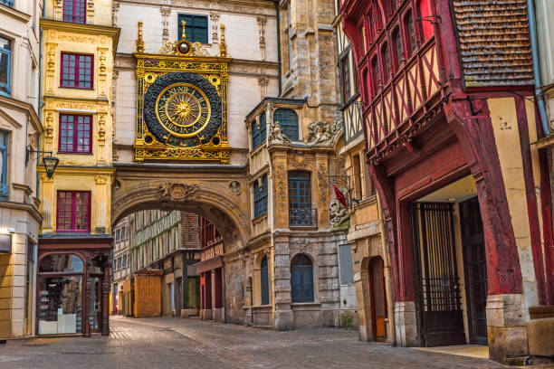
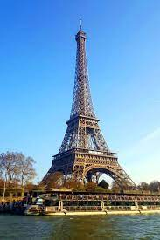
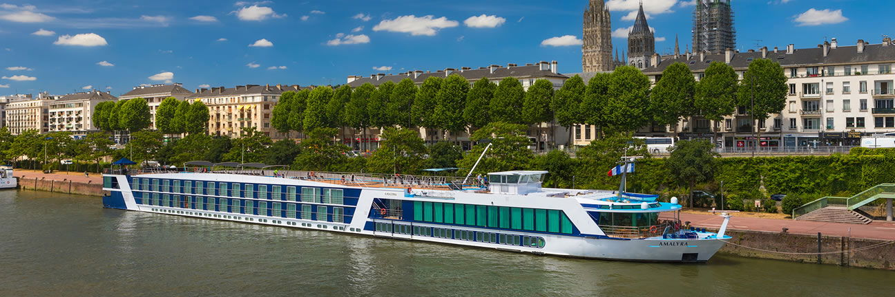
Sailing the River Seine roundtrip from Paris. Paris always sizzles while Normandy beckons with its stunning coastlines, incredible food and artistic beauty and remnants of the greatest of all WW2 battles – The D-Day Beaches of Normandy that turned the tide of the war. Monet’s Gardens and the charming harbor of Honfleur, will inspire you the same way as they inspired the Impressionists. We witness the site of Joan of Arc’s historic martyrdom. Relive the grandeur of royalty at Château de Bizy, once referred to as the “Versailles of Normandy.” Explore, admire, and blend a passion for the culture, architecture and timeless landscapes of Northern France all whilst sailing in the ultimate luxury of AmaWaterays aboard the AmaLyra.
ADVENTURES ON THE RIVER SEINE:
PARIS & NORMANDY
Paris, Normandy, D-Day Landing Beaches, Honfleur, Rouen, Vernon, Les Andelys, Le Havre
June 17-24, 2027

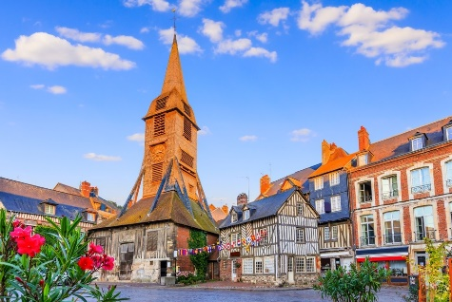
Larry & Cathy Gelwix will serve as your personal host and tour guides, along with expect local guides. Your choice of tours and shore excursions are included in your cruise fare, along with your meals onboard.


CALL TODAY FOR GROUP DISCOUNT CRUISE FARES!

MORRIS MURDOCK ESCORTED TOURS
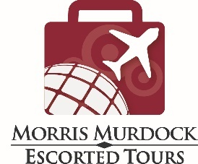
MORRIS COLUMBUS TRAVEL
Call your favorite Morris Columbus
Travel advisor, or Call Morris Murdock Escorted Tours at 1-800-809-9910 or online
at groups@morrismurdock.com
DISCOUNT CRUISE FARES
Cabin  Category | Cabin  Description | Published  Rate | Morris Columbus  Discount Rate | Savings  Per Person
E | Fixed upper windows, Piano Deck | $5,579 | $3,869 | $1,880
C | French Balcony, Violin & Cello decks | $7,178 | $4,969 | $2,209
B | French Balcony, Violin & Cello decks | $7,378 | $5,299 | $2,079
A | French Balcony, Violin & Cello decks | $8,478 | $5,459 | $3,019
Suite | French Balcony, Violin deck, 255 sq. ft. | $8,978 | $6,729 | $2,249
- Rates are per person based upon double occupancy. Call for single occupancy discount rates.
- Cabins are spacious at 170 sq. ft. The Suite is 255 sq. ft.
- Port charges: $250 per person are additional

DEPOSIT & CANCELLATION
- Deposit: $750 per person
- Balance Due: 16 Feb, 2027

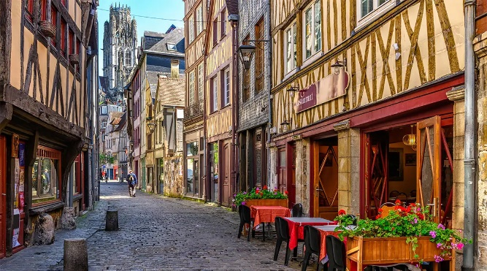
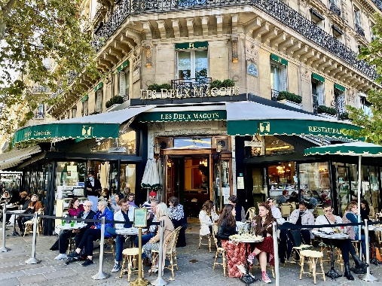
- Cancellation: All cancellations must be in writing and received by Morris Murdock Escorted Tours, 563 West 500 South, Suite 180, Bountiful, Utah 84010. Cancellation penalties and fees vary as per the date of cancellation. Consult your Morris Columbus Travel advisor for details.

CRUISE ITINERARY
Date | Visit | Description
June 17 | Paris | Explore the wonders of “The City of Light”. Overnight onboard.
June 18 | Les Andelys | Uncover the history of Château Gaillard, the former stronghold of Richard the Lionheart, situated on the chalk cliffs above the River Seine on the morning tour. Or, you can hike the banks of the Seine with sweeping views along the way. Walking the streets of the charming town of Les Andelys. We sail this afternoon meandering the Sights, sounds, and charms of the French countryside.
June 19 | Le Havre | During your time in Le Havre, set out on an excursion to the charming seaside village of Honfleur, renowned for its picturesque harbor and an inspiration for Impressionist artists. Walking the streets of Honfleur, a UNESCO designated town is a memory not to be forgotten. You should explore the picturesque Vieux Bassin (Old Port), admire the unique wooden Saint Catherine's Church, and visit the Eugène Boudin Museum to see art by the famous painter and his contemporaries.
June 20 | Le Havre, Normandy Beaches WW2, Caudebec en Caux | Experience the Normandy region with a variety on excursions. Relive the fateful D-Day, June 6, 1944, as you visit the Normandy Beaches, the cemetery at Colleville-sur-Mer, Omaha Beach, the artillery battery at Longues-sur-Mer and the village of Arromanches, where the remains of the floating harbor used during WW2 can still be seen. If you prefer, you can visit the Canadian and British beach landings. Alternatively, you can set out on a full-day excursion to the delicious Pays d’Auge region of Normandy. If you prefer something different, visit Caudebec-en-Caux and journey back in time with interactive exhibits and vessel at the Seine Museum.
June 21 | Rouen | Rouen is the capital of the northern French region of Normandy. This port city on the Seine played an important role under Roman rule and in the Middle Ages and boasts Gothic churches such as Saint-Maclou and Saint-Ouen. Medieval half-timbered buildings have been preserved in the cobblestone pedestrian zone. The cityscape is dominated by the towers of Notre-Dame Cathedral, which the Impressionist artist Claude Monet immortalized in numerous paintings. Spend the morning in medieval Rouen with a choice of several excursions. Join a walking tour and see the square where Joan of Arc was martyred, as well as the Medieval Quarter and Great Clock. Also available is the “Tastes of Normandy” tour, where you will be treated to the delicious flavors of the region, including its famous chocolate, Norman cheese, and cider.
June 22 | Vernon | Enjoy scenic cruising around Vernon before disembarking the ship for your excursion. In Vernon, France, you can see historic landmarks like the Château de Bizy and Collégiale Notre-Dame, and visit the Musée de Vernon. A major draw is the nearby town of Giverny, famous for Claude Monet's House and Gardens and the Impressionism Museum, while a stroll or bike ride along the Seine river is a pleasant way to see the scenic views.
June 23 | Paris | Travel to Auberge Ravoux in the heart of Auvers-sur-Oise, the last home of artist Vincent van Gogh in the attic rooms at the Ravoux Inn where in just 70 days he painted more than 70 works before his death. You will enjoy the exquisite architecture of the Château de Malmaison, the former home of Napolean and Josephine Bonaparte, also known as the “most beautiful and curious garden in Europe.” Later today, experience the “City of Light”, La Ville Lumière, from a unique perspective as you board a modern river boat at the Port de la Bourdonnais, located on the banks of the River Seine near the Eiffel Tower and glide along the river and underneath Paris’s ornate bridges. From the boat, you will take in the panoramic views of the city’s iconic buildings and monuments, including the Musee d’Orsay and the Notre Dame Cathedral. Overnight onboard.
June 24 | Paris | Disembarkation. You may finish your journey as you return home or extend your visit to Europe. Your Morris Columbus Travel advisor is pleased to assist with your travel arrangements and/or extended travel plans. Merci et au revoir!
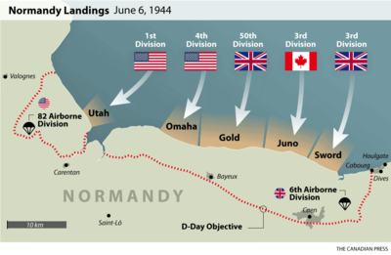
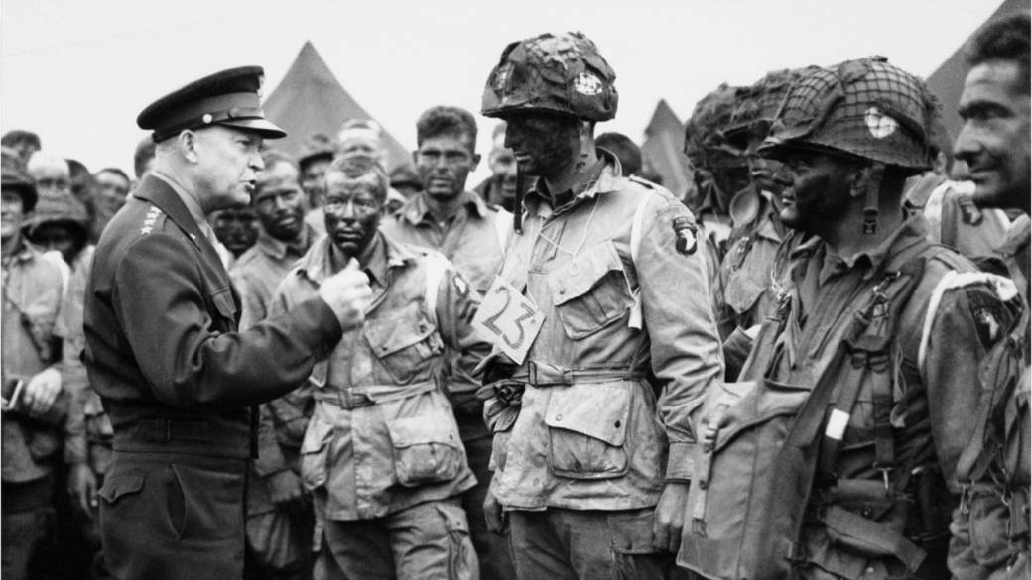

Introductory Terms and Conditions
(Full Terms & Conditions available on our website and included with each booking)


HEALTH & HYGIENE, MOBILITY and CANCELLATION POLICIES: By signing up for this or any of our tours, you are expressly agreeing to be bound by the TERMS & CONDITIONS contract that will be provided to you with your confirmation, specifically that you understand: i) All policies outlined therein regarding current health and hygiene requirements that may be required by the countries and locations visited; ii) The required mobility needed for the tour; and, iii) The Morris Murdock Escorted Tours cancellation policy may be more restrictive than a vendor or cruise line with which you are traveling.


INTERNATIONAL TRIPS: For all tours and cruises that include international air, a valid passport is required and must be valid for at least 6 months from the return date of the trip. Morris Murdock Escorted Tours must receive a copy of your passport information page by final payment date. Airlines have strict policies concerning name changes/corrections after tickets have been issued. If a name change/correction is required on your ticket, you will be required to cover the cost of any fees.

PASSPORT: For U.S. citizens a passport valid for at least six months beyond your return travel date to the United States is required. For Thailand, your passport must have at least one blank page for each entry stamp. For Cambodia, your passport must have at least one blank page for each entry stamp. An endorsement page is not considered an blank passport page.

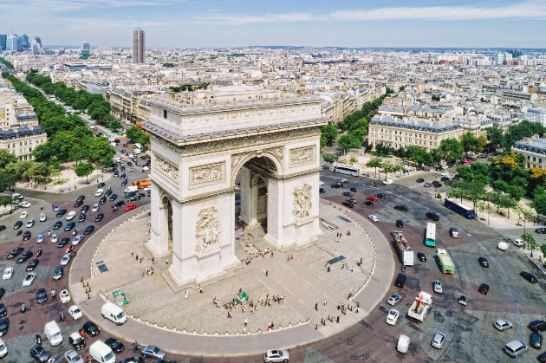


TERMS AND CONDITIONS: Morris Columbus/Morris Murdock Escorted Tours, ("Agent") gives notice that all services, reservations and arrangements for transportation, cruise, conveyance, hotel or lodging of any type, meals, sightseeing services, or any other activities made by Agent, are made by Agent as dual agent for the traveler/passenger and for the air carriers, hotels, sightseeing companies, transportation companies, cruise lines, and other companies (Suppliers) providing services for this program. As such, Agent shall not be liable for injury, damage, loss, accident, delay, or irregularity which may be occasioned either by reasons of defect in any vehicle or mode of transportation, through the acts, defaults, financial difficulty, bankruptcy, or omissions of the Supplier or person engaged in carrying out the arrangements of the trip or otherwise in connection therewith. Agent is not liable for delays and/or cancellations of services and resultant expenses or loss caused by acts of God, weather, disaster, government regulations, sickness or death, quarantine, strikes, war, terrorism, social or labor unrest, local laws, mechanical or construction difficulties, curtailment or disruption of transportation, abnormal conditions or other situations, actions, omissions or conditions outside Agent's control. Agent is not liable for loss of, or damage to, baggage or personal possessions. Agent and Supplier reserve the right to alter or cancel the itinerary or substitute services as conditions require or for the safety of traveler/passenger. Passengers must be in good health and able to care for their own needs. Please contact us regarding any health concerns you may have or if you need to bring any specialized medical equipment such as wheelchairs, oxygen tanks, C-Pap, etc. so that we can determine if Supplier can accommodate your equipment. Tour directors on the trip cannot be of assistance with such needs. We reserve the right to remove travelers/passengers from the group at their own expense if the care of or actions of a traveler/passenger become detrimental to the functioning of the tour. Payment of deposit(s) as outlined in this agreement shall be deemed consent to be bound by the terms and conditions of this agreement. Airline schedule changes, mechanical or weather delays may affect flight times. Your connecting flights and/or transportation to and from the start and end point, whether issued by Morris Columbus Travel/Morris Murdock Escorted Tours or on your own arrangement, may be affected. Morris Columbus Travel/Morris Murdock Escorted Tours is not responsible for misconnections, delays, and/or cancellations.

MORRIS MURDOCK ESCORTED TOURS –
Call your favorite Morris Columbus Travel advisor, or call
Morris Murdock Escorted Tours at 1-800-809-9910 or online at
groups@morrismurdock.com

